**Name: Wardshan Essam Elsaid Section:20**

**Name: Yussef Ayman Omar Section:20**

**Name: Youssef Halem Youssef Section:20**

**Name: Youssef Abdelbaay Section:20**

**Statistical Analysis and its Applications**

**Dr: Mahmoud Mounir**

**FCIS**

**2018/2019**

**Facial Expression Recognition**

**TABLE OF CONTENTS**

**1.0 GENERAL INFORMATION……………….1-1**

**1.1 System Overview…………………………………1-1**

**1.2 Organizing of the Manual….…………………1-2**

**2.0 SYSTEM SUMMARY…………………………2-1**

**2.0.1 Figure 1……………………………………………2-1**

**2.0.2 Figure 2……………………………………………2-1**

**2.1 System Configuration……………………………2-1**

**2.2 User Access Levels…………………………………2-2**

**3.0 GETTING STARTED……………………………3-1 3.1 What to Install……………………………………….3-1**

**3.2 First Window………………………………………….3-2**

**3.2.1 Figure 3……………………………………………2-1**

**3.3 Video Capturing……………………………………..3-3**

**3.3.1 Figure 4……………………………………………3-3**

**3.3.2 Figure 5……………………………………………3-3**

**3.3.3 Figure 6……………………………………………3-3**

**3.4 Exit System……………………………………………..3-4**

**1.0 General Information**

Facial emotions are important factors in human communication that help us understand the intentions of others. People infer the emotional states of other people , such as joy, sadness and anger using facial expressions and from here we started to think of this idea. Facial expressions are one of the main information channels in interpersonal communication so we thought why we dont Train computer to recognize it itself?

**1.1 System Overview**

Facial Expression Recognition is a Project, allows detecting our Emotions in front of the Camera in a Live Video, First of all it detects the Area that your Face is in it and then it has been trained to recognize which emotion do you have.

**1.2 Organizing of the Manual**

The user’s manual consists of three sections: General Information, System Summary, Getting Started

General Information section explains in general terms the system and the purpose for which it is intended

System Summary Section provides a general overview of the system. The summary outlines of the system’s configuration, user access levels

Getting Started Section explains what to install to run the project and step by step how to handle the system

**2.0 System summary**

Facial Expression analysis includes both measurements of facial motion and recognition. The general approach to automatic facial expression analysis (AFEA) consists of three steps: face acquisition, facial data extraction and representation, and facial expression recognition. As shown in figure 1

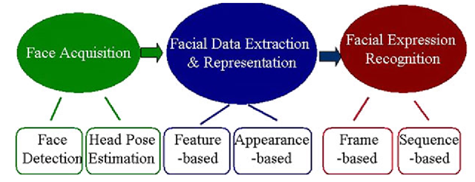

Face acquisition is a processing stage to automatically find the face region for the input images or sequences. We use Haar cascade for that. The Haar cascade is basically a classifier which is used to detect face for each frame. After face is located, the next step is to extract and represent the facial changes caused by facial expressions In Facial feature extraction for expression analysis, there are mainly two types of approaches: geometric feature-based methods and appearance-based methods. The geometric facial features present the shape and locations of facial components (including mouth,eyes,brows,nose,etc.) . The facial components or facial feature points are extracted to form a feature vector that represents the face geometry. With appearance-based methods, image filters, are applied to either the whole-face or specific regions in a face image to extract a feature vector.

Facial expression recognition is the last stage of AFEA systems: the facial changes can be identified as facial action units or prototypic emotional expressions as shown in figure 2

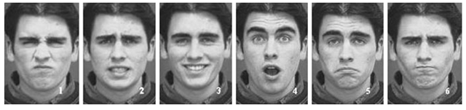

**2.1 System Configuration**

This project uses opencv library it’s the main library in our project, project can be used in any operating system , The language in which the project is programmed is python .

**2.2 Users Access Levels**

Everyone can use the application and detect his/her facial expressions

**3.0 Getting Started**

To Run the project you should extract the rar file in your computer and Have a python IDE

**3.1 What to Install**

You should install this Libraries in your IDE (Pillow, numpy, opencv-python, opencv-contrib-python) to run the project without errors

**3.2 First Window**

This is the first window will appear when you run the project, you can click start to start detecting your facial expressions or you can close it from the icon or you can maximize the window as shown in figure 3

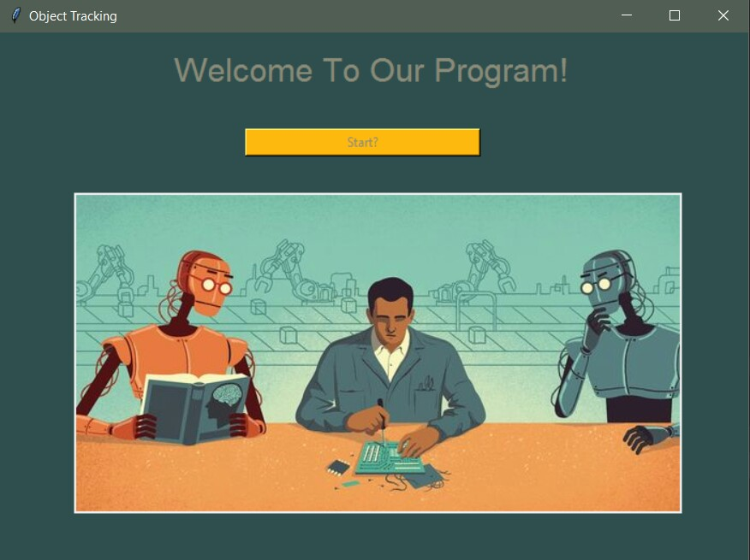

**3.3 Video Capturing**

Once you click start then will appear another window and the camera of your pc will be opened , then you can make a happy expression or sad or angry and it will show you which expression do you have , as shown in figure 4,5,6

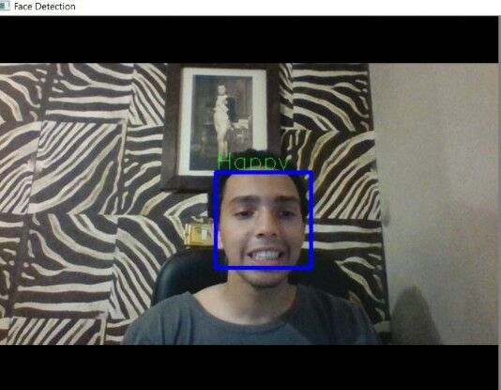 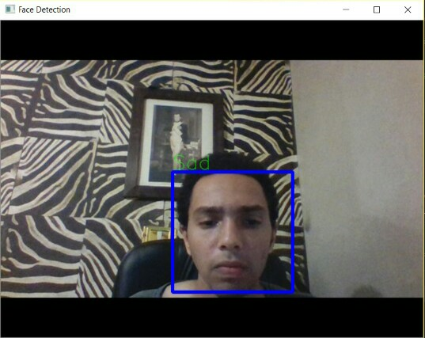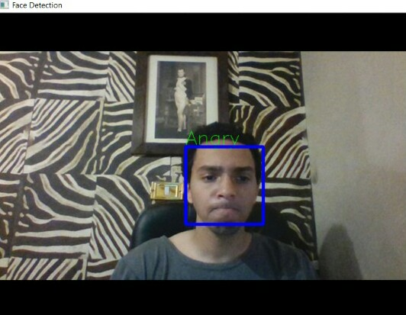

**3.4 Exit System**

To Exit System you should hit ‘q’ letter in the keyboard , and that’s all, hope you enjoy trying the project.